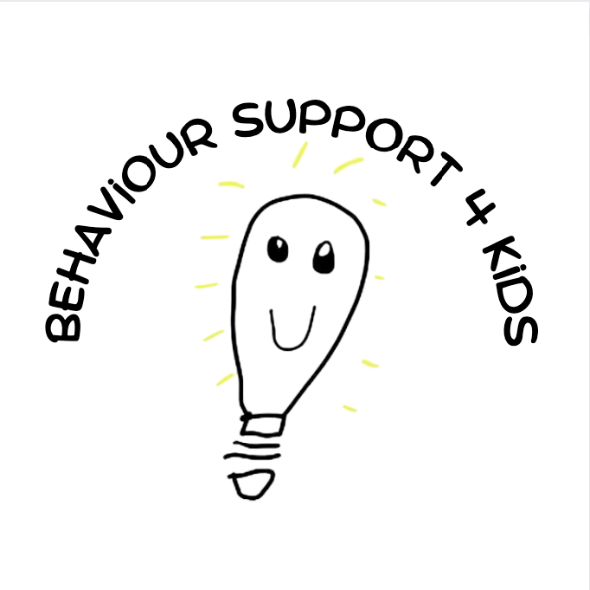

This Client Information document gives you information on who we are and what you can expect from accessing our services

How to use this document
This information is written in an easy-to-read way.
This is a summary of another document called Client Information. You can get the other document by asking us.
You can ask for help to read this document.
A friend, family member or support person may be able to help you.

About Us
We aim to support, advocate for and empower people with Disabilities. We do this by providing information, support and services.

Client Services Charter
- You are important and must be respected.
- You can be supported to access services that suit your needs, age, lifestyle and cultural beliefs
- You can make your own choices, and be supported and informed to do that, including to take calculated risks
- You have a right to be safe and to be protected from discrimination, violence, abuse and neglect
- You can refuse to be involved or say no at any time

- You should be informed on matters about you including your service rights
- We will treat your personal information as confidential
- You can ask questions, provide feedback or make a complaint.

How to contact us
Director, Emma Zarcinas
Call: 0448027091 - Monday to Friday, 9: 00am-5:00pm
Email: Emma@behavioursupport4kids.com.au

We value your feedback

It is important that we know if we are doing a good job. It is also important to know when there are problems.
It is important for us to know if you are not happy with the services you use.
Your feedback is important.
It can help make services better for you and other people.

What is feedback?

Feedback is when you tell someone they gave you a good service. Feedback is also when you tell someone you are not happy with a service. It is also when you tell someone or make a complaint.

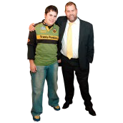
You can ask a family member, carer or friend to help you give feedback. You can also use an advocacy service.
Advocacy will work with you to help you speak up for yourself.

How can I give feedback or make a complaint?
You can give feedback:
▪ in writing
  - in person
  - on the phone
  - by email
  - on a form from us

What happens after I make a complaint?

- If your complaint is small and easy to fix, it should be fixed straight
- away.
- If it is a bigger complaint, it might take longer.
- You should be told what is happening and how long it might take.
- If you are worried or have not heard anything for a while, you should contact us again.
- If you are still unhappy, you can talk to our Director, Amy Hall.
- If you are still unhappy and you have followed all these steps you can contact the Ombudsman, or the NDIS Commission.
- NDIS Quality and Safeguards Commission – Ph: 1800 035 544 TTY 133 677
- A family member or advocate can help you do this

Privacy

When we give you a service, we will need to ask you for some personal information.
We ask for this information so that we can make sure you are getting the service that you want and that your needs are met.
If you don’t want to answer some questions that’s ok! Some questions you don’t have to answer if you don’t want to.
There are some really important questions that we will need information about to give you a service.

The information you give us is PRIVATE and only shared with those who need to know it to give you a service.
We will ask your permission about who can see your information.
If something changes for you, for example your goals or maybe your health needs change, please tell us so we can update your information.

You can ask to see your personal information by contacting us.

Client Protection
We work hard to protect you from abuse and neglect Abuse is when someone hurts you.
Abuse is never ok.

It could be by:
- physical abuse - hurting your body
- emotional abuse - hurting your feelings or threatening you

Client Safety
- financial abuse - taking or controlling your money
- sexual abuse - does something to you in a sexual way that is not ok
- neglect - not looking after you properly

If we think you are being abused, treated badly or in danger we will help you.
We will follow the law and tell the right people.

We work hard to keep everyone safe.

We plan our supports and services to keep you safe.

If there is a problem or accident, we investigate the incident and look at what to do to stop it happening again.

We will talk to the person who was hurt about the incident and what the investigation found.

