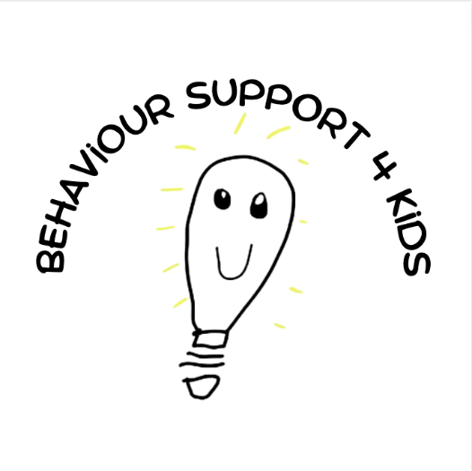

Service agreement
Easy Read version

This service agreement is between

you – ,

who lives at

,

and

us – Behaviour Support 4 Kids – your NDIS service provider.

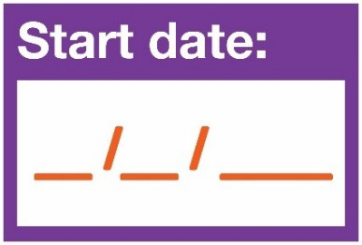
This agreement starts on / / .

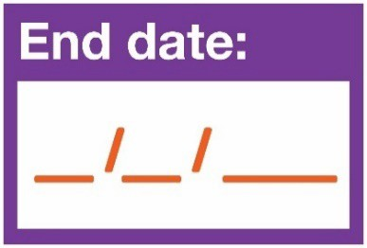
This agreement ends on / / .

How to use this service agreement

Emma Zarcinas at Behaviour Support 4 Kids

wrote this service agreement.

When you see the words ‘we’ or ‘us’, it means
Emma Zarcinas .

We have written this service agreement in an easy to read way.
We use pictures to explain some ideas.

You can ask for help to read this service agreement.
A friend, family member or support person may be able to help you.

What’s in this document?
What is a service agreement? | 5
Responsibilities | 7
What you need to do | 8
What we need to do | 9
What both of us need to do together | 10
Paying for your supports | 12
Changing this agreement | 15
Ending this agreement | 16
Cancelling services | 17
Tell us what you think | 18
Your Schedule of Supports | 19
For people who use the NDIS only | 23
Contact us | 22

What is a service agreement?

This service agreement is about the services and supports you will get from us.

It explains the supports that we will give you.

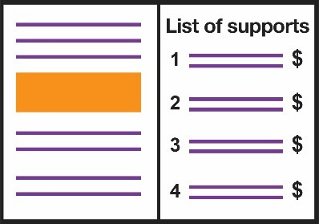
At the end of this document, there is a list of:
- your supports
- their prices.

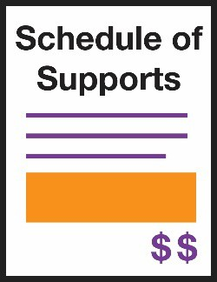
We call this your Schedule of Supports.

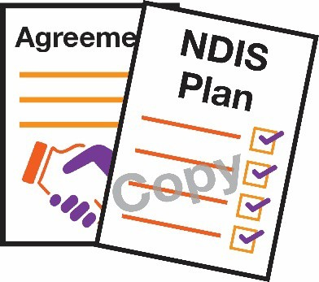
There is also a copy of your NDIS plan at the end of this document.

This agreement also explains:

- what you can expect from us

- what we expect from you.

Responsibilities

Responsibilities are things that:

- you need to do

- we need to do

- both of us need to do together.

What you need to do

You need to:

- tell us how you want to get your supports

- tell us 48 hours before if you want to cancel an appointment

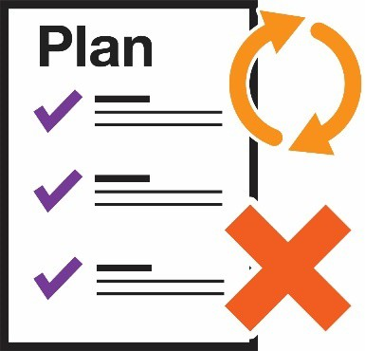
- tell us as soon as possible if your plan changes or ends.

What we need to do

We will give you:

- supports that meet your needs

- supports when you want them

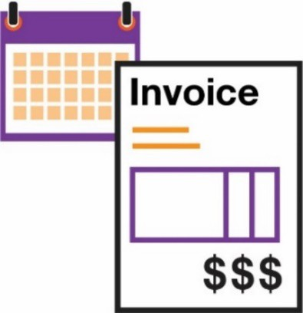
- an invoice for your supports at least once a month if you self manage.

What both of us need to do together

We both need to:

- treat each other kindly and with respect

- work out a plan for your supports

- check how your supports are going, at least once a year

- talk to each other about your supports and funding

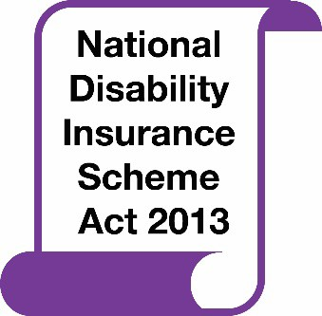
- follow NDIS laws – the National Disability Insurance Scheme Act 2013

- keep the paperwork for your supports

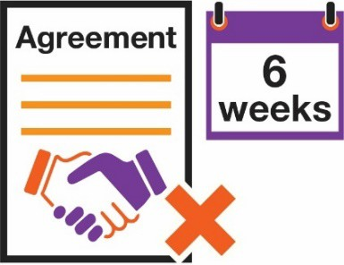
- give 6 weeks’ notice if this agreement needs to end

- listen to feedback

- fix problems quickly.

Paying for your supports

Funding is the money to pay for your supports.

Tick the box to show where your funding comes from:

◻ the National Disability Insurance Scheme (NDIS)

If the National Disability Insurance Agency (NDIA) takes care of your funding, they will pay us for your supports.

If you have a Plan Management Provider, they will pay us for your supports.

If you manage your own funding, you need to:

- have enough funding to pay for our services

- pay for travel costs if you manage your own transport funding.

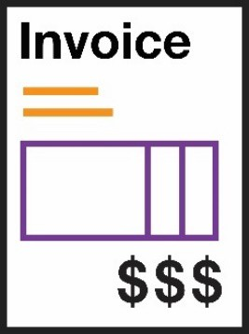
We will send you invoices that tell you how much you need to pay.

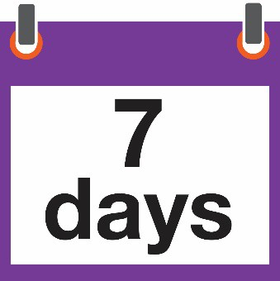
You will need to pay those invoices within 7 days.

If you don’t, we might not be able to provide you with support.

Changing this agreement

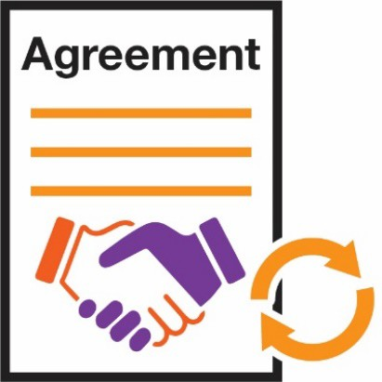
This agreement might need to change.

You might want to change it. We might want to change it.

We will talk to you about any changes.

Ending this agreement

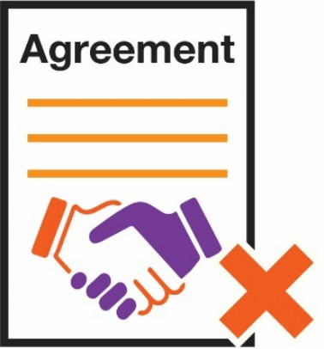
You can end your service agreement if we can’t give you the supports you need.

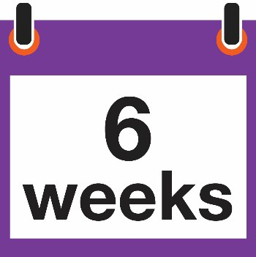
You need to tell us 6 weeks before you want the agreement to end.

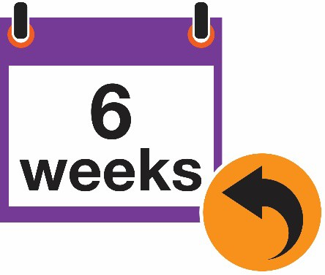
If we need to end the agreement, we will tell you 6 weeks before the date.

Cancelling services

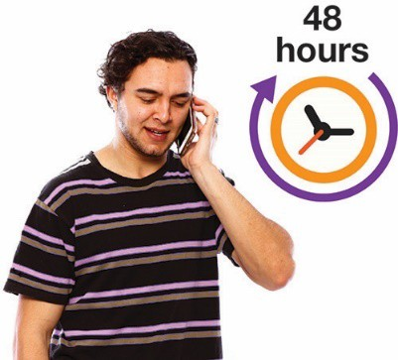
You must tell us if you need to cancel an appointment at least 48 hours before.

We will have to charge you a fee if you don’t tell us.

I

Tell us what you think

It’s important that we know how you feel about our service.

You can:

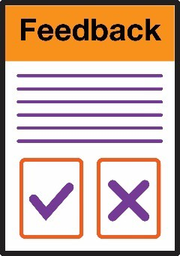
- give us feedback – tell us how things are going.

- make a complaint – tell us if something is wrong.

If you don’t want to talk to us, you can contact the NDIA:

1800 800 110

www.ndis.gov.au

Making this agreement

Please read and sign this page.

I understand and agree to everything in this agreement.

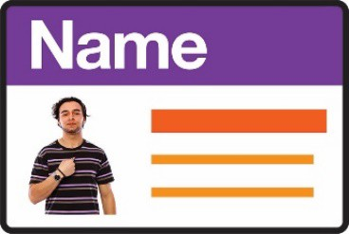
Your name

Your signature

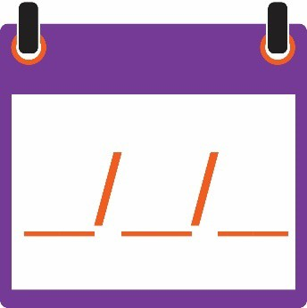
Date

/ /

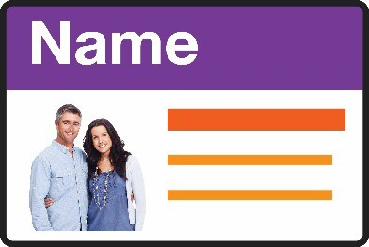
Your parent, nominee or guardian’s name

Your parent, nominee or guardian’s signature

Date

/ /

Your co-ordinator or contact from

reads and signs this page.

I accept this agreement for

.

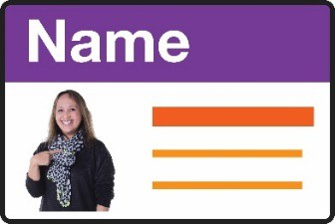
Staff member’s name

Signature

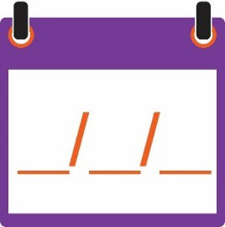
Date

/ /

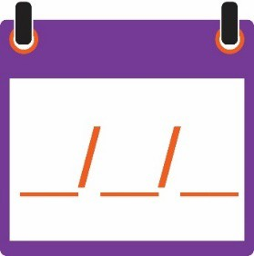
This agreement needs to be checked on or before

/ /

Contact us

PH: 0434427576

Emma@behavioursupport4kids.com.au

19 Rundle St
Kent Town
SA, 5067

www.behavioursupport4kids.com.au

Your Schedule of Supports
For people who use the NDIS only

Name of support | About this support | How much this support costs

